Microsoft account
[Company name]
[Date]
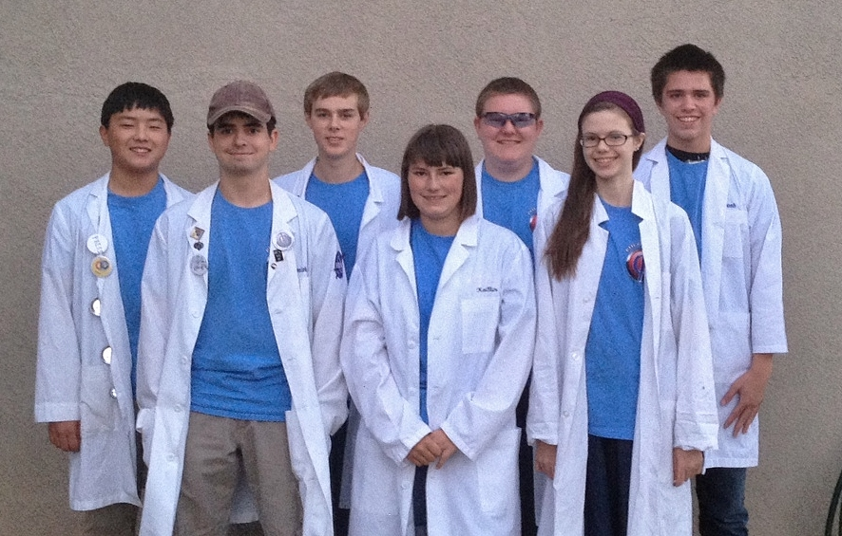
PHI Ω ENGINEERING NOTEBOOK
BIOS
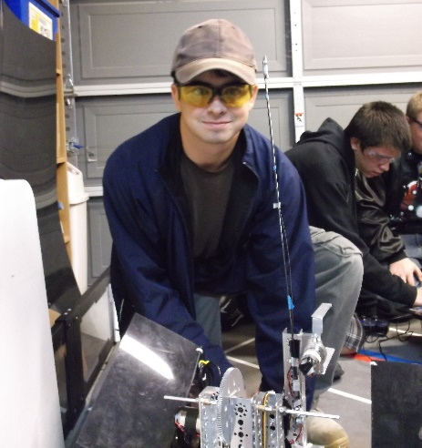
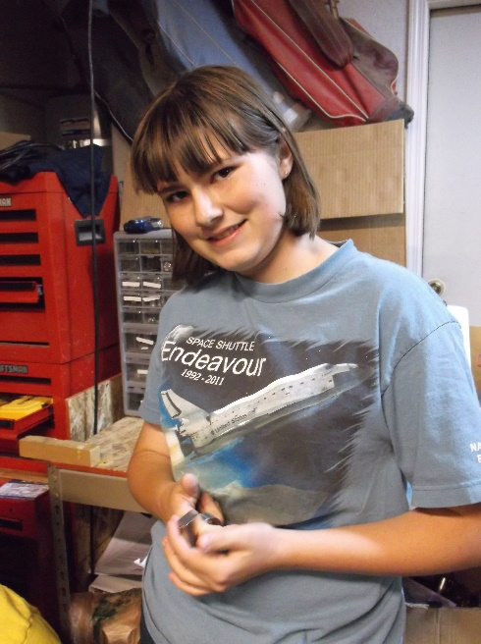
Jonathan Lokos 4th year on team
FAVORITE JOB ON TEAM: Team lead, hardware, 3D modeling, and driving.
HOBBIES: Robotics, airsoft, SCUBA diving, kayaking, and hiking.
INTERESTING FACTS: I am known in the robotics community as the “Beard of Knowledge”. I have been building and designing since I was three years old.

Kaitlin Cox 3rd year on team
FAVORITE JOB ON TEAM: Driving the robot and working in the notebook, as well as learning to write basic software
HOBBIES: Creative writing- particularly medieval fantasy stories and fanfiction- art, computer programming and game design, and roleplaying
INTERESTING FACTS: Over the course of the 2013/2014 school year I wrote the rough draft for a novel that is more than 110,000 words in length. I am currently editing the manuscript. I am also attempting to make a computer game using the Construct 2 platform. I am a keraunomaniac, which means I have an abnormal obsession with lightning. Not everything I say is meant to be taken literally.
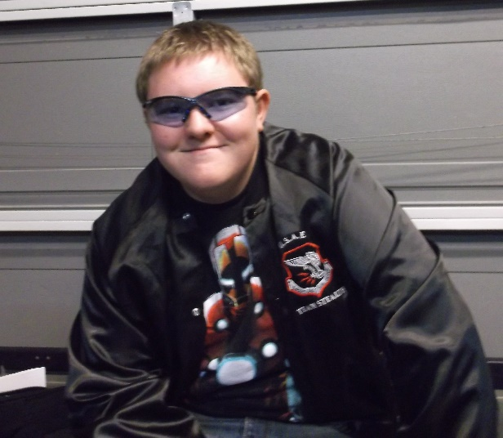
Eddie Pierce 3rd year on team
FAVORITE JOB ON TEAM: Hardware design, LabView programming
HOBBIES: Playing clarinet, PC gaming, novel writing, sketching, airsofting
INTERESTING FACTS: I have been known on the team as the designated target for all robots. For my first year on the team, I was called the Dementor, but that has since changed to Bones.
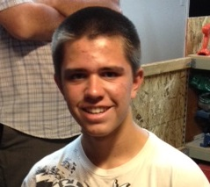
Noah Killian 2nd year on team
FAVORITE JOB ON TEAM: Software
HOBBIES: Programming, Cubing, League of Legends, Electronics
INTERESTING FACT: I’m too lazy to procrastinate so I’ll procrastinate later.

Holly Creech 1st year on team
FAVORITE JOB ON TEAM: Working on the notebook, and learning hardware.
HOBBIES: Playing the piano, teaching the piano, and writing.
INTERESTING FACTS: I love owls, chocolate, listening to music, and spending time with friends.


Hanna Creech 1st year on team
FAVORITE JOB ON TEAM: Hardware
HOBBIES: Photography, Baking, Piano (music), Swimming, And Drawing
INTERESTING FACTS: I enjoy my pets especially my dog and guinea pig. I’ve been doing piano for over 6 years and the flute for 1. My favorite color is blue.

Sergei Cox 1st year on team
FAVORITE JOB ON TEAM: Hardware
HOBBIES: Softball, building things, reading.
INTERESTING FACTS: People call me different things and say my name wrong. I’m the weirdest person I know.

Anna Leland 1st year on team
FAVORITE JOB ON TEAM: Hardware
HOBBIES: Running Hurdles, Reading, SCUBA Diving, Script Writing
INTERESTING FACTS: I manage my school’s Cross Country Team and I’ve directed my school’s play for the past three years.
Becky Pierce 1st year on team
FAVORITE JOB ON TEAM: Software
HOBBIES: Playing volleyball and softball, running cross country and track, baking, piano
INTERESTING FACTS: I’ve been homeschooled my whole life. I helped start an FLL team in 2011. I used to be on a bowling team. I hate looking for nonexistent screws. I love the Dodgers.

MEETING LOG

SAMPLE MEETING LOG- MM/DD/YYYY
HARDWARE
Author initials

SOFTWARE
Author initials

NOTEBOOK AND/OR OUTREACH
Author initials

ATTENDENCE

MEETING LOG- 9/8/2014
HARDWARE
Author initials
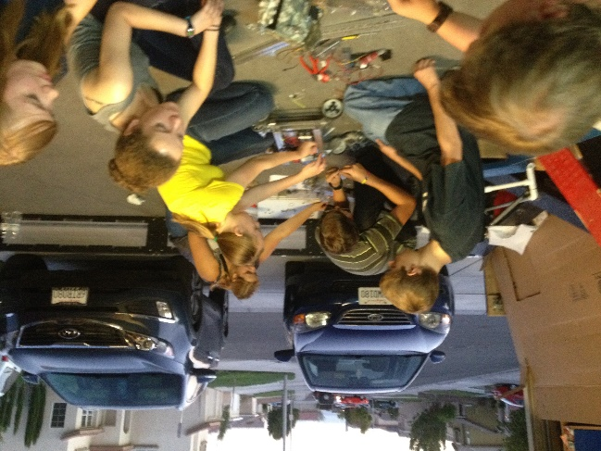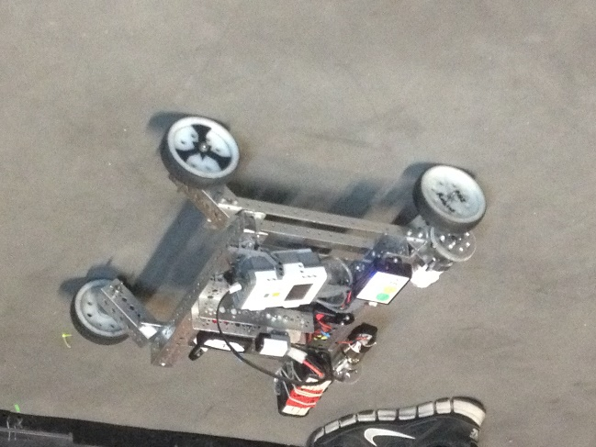
SOFTWARE
NK
Our goals for tonight were to give some of the freshmen an intro to programming in RobotC which is the language our team uses.

Tonight we explained the basics of RobotC to the freshmen interested in learning it. We explained pragmas, includes, and basic motor controls.

ATTENDENCE- Cierra, Kayla, Kaitlin, Hanna, Holly, Joseph, Mike, Noah, Anna, Jonathan, Josh, Luke, Cole

MEETING LOG- 9/11/2014
HARDWARE
JL
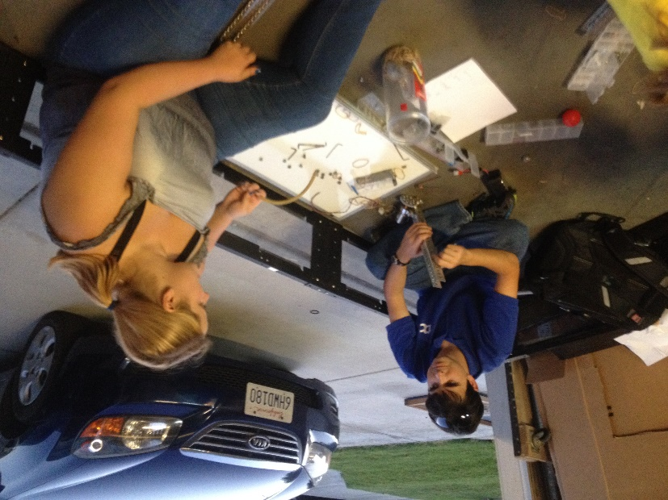
Our goals for tonight where to rebuild both of our 2013-2014 chassis so we could mount prototypes and test them. We also wanted to brainstorm further ideas for ground intake systems.

Tonight we accomplished rebuilding and wiring both robots. We succeeded at mounting some prototypes on one of the robots and the freshmen learned how to program the other. We familiarized some of the freshmen with parts of the TETRIX kit. We also brainstormed an inverted funnel for scoring balls in the tubes.

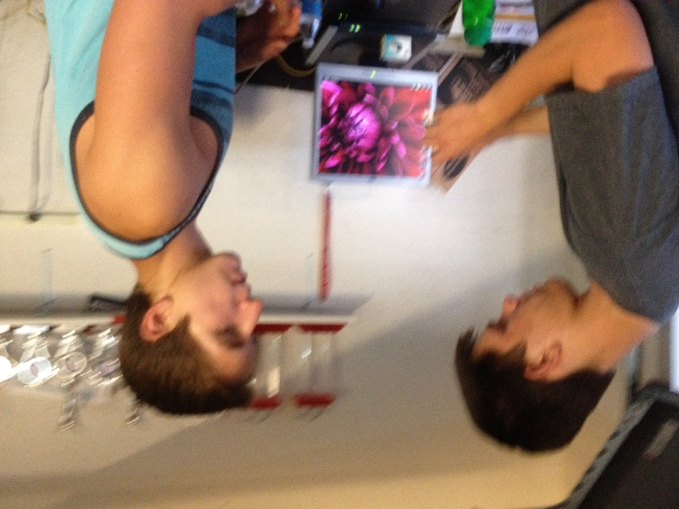
SOFTWARE
JM
We further instructed freshmen on programming, teaching them about pragmas, how to control the motors, and how to create autonomies. We also explained basic C syntax.

NOTEBOOK
KC
Tonight we set up a syncing application to allow us to sync important files such as the Engineering Notebook, code files, and pictures between computers. We also set up a new, more detailed format for the meeting log.

ATTENDENCE- Cierra, Kayla, Kaitlin, Hanna, Holly, Mike, Noah, Anna, Jonathan, Josh, Luke, Becky, Eddie, Scott, Sergei

MEETING LOG- 9/15/2014
HARDWARE
Author initials

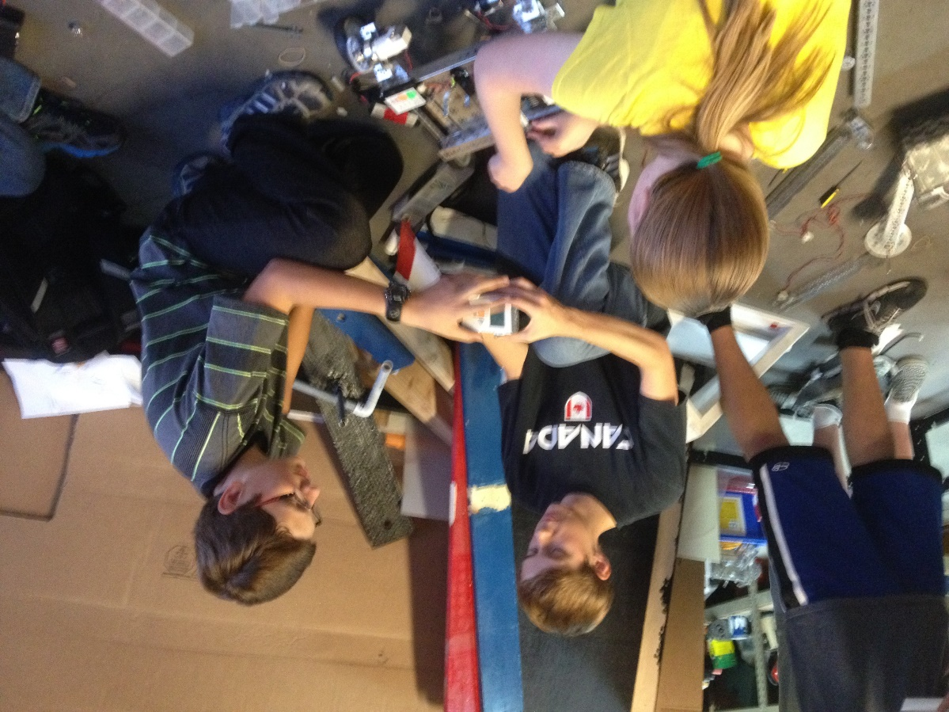
SOFTWARE
NK
We continued to work with the freshmen and their coding skills. As they learn more, they will be in charge of the very basic autonomies and tele-ops while those of us that are more experienced will work with the more advanced concepts.

ATTENDENCE-

MEETING LOG- 9/18/2014
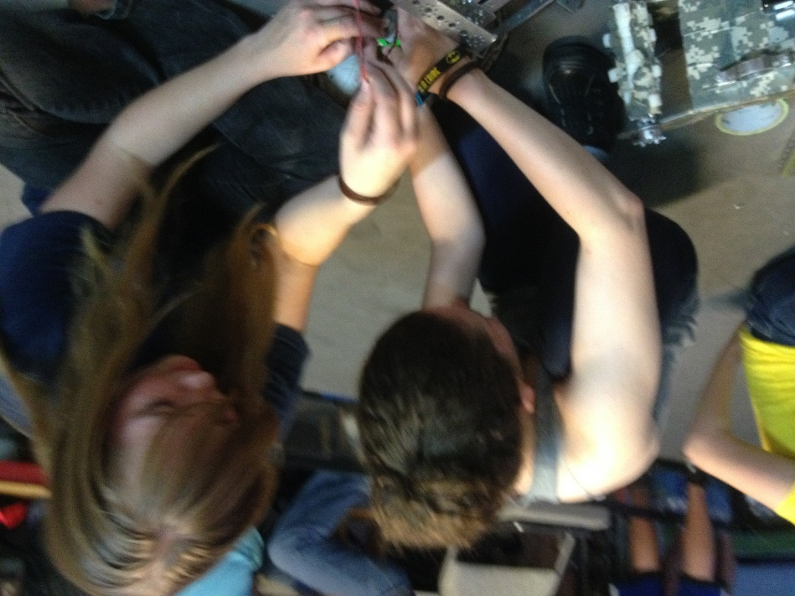
HARDWARE
SC
We wanted to finish our prototypes, make more prototypes, and build our game field.
The main prototype that we have been working on is a conveyor belt that picks up balls and carries it up into a bucket. The bucket is mounted on a linear slide that carries it with the balls to the height of rolling goals. We also made a smaller tube that is around the conveyor belt to help both ball sizes go up through it into a bucket and extended the width of the flaps of card board so that the conveyor belt could pick up both sizes of balls, and made a bucket to hold the balls to score them into the goals. In addition to this, we prototyped some ideas for grabbing the rolling goals.

SOFTWARE
JM

We discussed finding distance from acceleration and finding distance from IR sensor values. We were theorizing ways to use double integration so that we would be able to ascertain accurate distances from the accelerometer and are now trying to find equations that will allow us to do so. Unfortunately, double integration can greatly multiply error so we need to find a way to make measurements as accurate as possible. We are also theorizing ways we can find distance with IR finding the angles we are from the IR emitter and then using trigonometry to find our relative position.

ATTENDENCE-

MEETING LOG- 9/22/2014
HARDWARE
CS
Tonight we finished off the field build by assembling the last parts of the ramp, and adding the tapped lines to the floor to mark off the specified zones/goals.
Our first prototype was a small “L” shaped piece designed with a bendable edge that would fit on the back of the robot. The robot would drive backwards bending the edge to snap onto the rolling goals, and then proceed to drive to the scoring zone. This piece could also be modified with a servo to allow it to be raised/lowered onto the rolling goal lip.
Our next prototype we fitted onto a square-bot to get a better look at it. It consisted of a conveyor belt fitted to raise the whiffle balls into a holding container. Once the container was filled, an arm would proceed to raise the container, and dump the balls into whatever rolling goal was desired.
Our third prototype for the nigh still needs some work. It is designed to be a tube that will pull in the whiffle balls using foam prongs attached to motors. A sensor will count the amount pulled in, and will stop the mechanism at the desired amount. After this, the robot will be driven up to a rolling goal, and the balls will be deposited out of a “U” shaped piece at the top of the container. In order for this design to work, we still need NASA to cut out certain sections of the tube, and supply additional parts.
Our final design for the night consisted of an arm, holding area, and an elevator. We designed an arm to catch balls, and put them into a sloped holding container. The balls would all roll to the corner where an oval shaped conveyor would scoop the balls out, flip over, and dump them into a desired container on their “O” shaped path.
SOFTWARE
Author initials

ATTENDENCE-

MEETING LOG- 9/25/2014
HARDWARE
CPB
Some of the things we did tonight, we built some prototypes. One of the prototypes we built was a little box hand that helps us pick up balls. It’s workable and easy for someone to operate. Another prototype that we did was, attach a second linear slide for extra height. Finished wiring the bot. Finished building the shield around the conveyor belt, to contain the balls when we pick them up. Create a funnel to help guide the balls into conveyor belt.
SOFTWARE
NK
We are looking at the various ways to perform a double integration on our accelerometer values to determine distance travelled while minimizing error. Some of the methods we have encountered are Simpson’s Rule, Trapezoidal integration, rectangular integration, and Boole’s rule. Trapezoidal appears to be the one we will use.
ATTENDENCE-

MEETING LOG- 9/29/2014
HARDWARE
HRC
Tonight we worked on prototypes. One of the prototypes we worked on is a bucket. The bucket (AKA Holly JR.) is lifted by a linear slide. The purpose of the bucket is for the balls to drop into it and for it then (using the linear slide) to take the balls up and drop them into the scoring goals. The bucket can also tip for more accurate and more consistent scoring. Another prototype we worked on is a way to pick up balls. It uses zip ties and no slip grip in a rectangular box. We also discovered some things we could work more on to improve.
SOFTWARE
Author initials

ATTENDENCE

MEETING LOG- 10/2/2014
HARDWARE
Author initials
SOFTWARE
Author initials

ATTENDENCE-

MEETING LOG- 10/6/2014
HARDWARE
EP
Tonight, Phi Alpha and Omega opened in prayer together, then each team discussed what they would work to accomplish during the meeting. After settling what each of the team members was working on, the teams split ways to work towards their individual goals. The meeting’s work got started with an in-depth stress test of the 3D printed plastic nacelles for Khan’s chassis. A small group constructed a simple mount for a small video camera one team member owns. After the mount was completed, it was mounted to the robot in a position such that the camera could watch the springing motions of the nacelle. After several short drops off the side of the ramp, one of the front nacelles broke in two. Through detailed examination, we observed that the plastic sheared from front to back, a place in which we were warned that shearing could occur if put under stress. Fortunately, we had a spare on hand and the nacelle was quickly replaced. After thinking of a fix to this problem, we accessed the computer model for the part and increased the thickness of the walls by three. Then the new part model was sent to our 3D printer contact for construction. Soon after, we discovered the other front nacelle was developing a crack as well. The chassis was set to the side until we could get the better replacement parts and the group that was working on the chassis turned to other projects.
During the stress testing, a separate group of Phi Omega members was working another prototype for scoring. This prototype is a large bucket with two brushes on the top for intaking the balls. Then it would dump the balls out the back of the bucket. The brushes were recycled from a previous scoring system from the previous year’s challenge.
One set of team members that moved from the chassis of the robot began reworking another of the few prototypes we have. The “Da Vinci” had a major redesign and the paddle-like intake mechanism was disassembled to later be replaced with a belt system. The rest of the team members that were previously working on the chassis helped Phi Alpha with their robot.
Shortly before the meeting ended, we stopped building to clean up the mess we had made. Then we had a short debrief detailing what each group had accomplished. Finally, the meeting was ended with prayer.

SOFTWARE
Author initials

ATTENDENCE

MEETING LOG- 10/9/2014
HARDWARE
KC
Today we repaired the wheel system with new 3d-printed parts after we discovered that the original models were prone to cracking when subjected to stress. We also worked on the intake tube, and began work on the arm that will lift it.
SOFTWARE
Author initials

ATTENDENCE- Kaitlin, Jonathan, Sergei, Eddie, Holly, Hanna

MEETING LOG- 10/13/2014
HARDWARE
Author initials

SOFTWARE
Author initials

ATTENDENCE

MEETING LOG- 10/16/2014
HARDWARE
SC
We made some chain and cut metal for the three joint arm. We also drilled the holes that the chain gear runs on and geared it to power the arm. Then when we tried to assemble it. We found that the length between the gears that the chain runs on was either too long or too short, so we marked where the gear would need to go by holding the chain on the gear and marking it. Then we drilled the holes and tried to mirror that on the other pieces of metal.

SOFTWARE
Author initials

ATTENDENCE

MEETING LOG- 10/20/2014
HARDWARE
Author initials

SOFTWARE
Author initials

NOTEBOOK AND/OR OUTREACH
Author initials

ATTENDENCE

MEETING LOG- 10/23/2014
HARDWARE
Author initials

SOFTWARE
Author initials

NOTEBOOK AND/OR OUTREACH
Author initials

ATTENDENCE

MEETING LOG- 10/27/2014
HARDWARE
Author initials

SOFTWARE
Author initials

NOTEBOOK AND/OR OUTREACH
Author initials

ATTENDENCE

MEETING LOG- 10/30/2014
HARDWARE
Author initials

SOFTWARE
Author initials

NOTEBOOK AND/OR OUTREACH
Author initials

ATTENDENCE

MEETING LOG- 11/3/2014
HARDWARE
Author initials

SOFTWARE
Author initials

NOTEBOOK AND/OR OUTREACH
Author initials

ATTENDENCE

MEETING LOG- 11/6/2014
HARDWARE
Author initials

SOFTWARE
Author initials

NOTEBOOK AND/OR OUTREACH
Author initials

ATTENDENCE

MEETING LOG- 11/10/2014
HARDWARE
S.C.
Our goals were to finish wiring our robot, do drivers practice and to put a servo on our tube that flips and scores the balls. We needed a long wire to run up our linear slide but we didn’t have the wire we needed. So we put a couple braces to stabilize the linear slide and we wired our winch that lifted the slide. We thought that it would be good to have another robot so that some of the new people could practice traveling around and playing defense so we built another square robot. The square robot is just a simple chassis that is run by two motors and some chain. The last thing we did was to test the individual units and make tweaks to it.

SOFTWARE
Author initials

NOTEBOOK AND/OR OUTREACH
Author initials

ATTENDENCE

MEETING LOG- 11/13/2014
HARDWARE
Author initials

SOFTWARE
Author initials

NOTEBOOK AND/OR OUTREACH
Author initials

ATTENDENCE

MEETING LOG- MM/DD/YYYY
HARDWARE
Author initials

SOFTWARE
Author initials

NOTEBOOK AND/OR OUTREACH
Author initials

ATTENDENCE

MEETING LOG- MM/DD/YYYY
HARDWARE
Author initials

SOFTWARE
Author initials

NOTEBOOK AND/OR OUTREACH
Author initials

ATTENDENCE

MEETING LOG- MM/DD/YYYY
HARDWARE
Author initials

SOFTWARE
Author initials

NOTEBOOK AND/OR OUTREACH
Author initials

ATTENDENCE

MEETING LOG- MM/DD/YYYY
HARDWARE
Author initials

SOFTWARE
Author initials

NOTEBOOK AND/OR OUTREACH
Author initials

ATTENDENCE

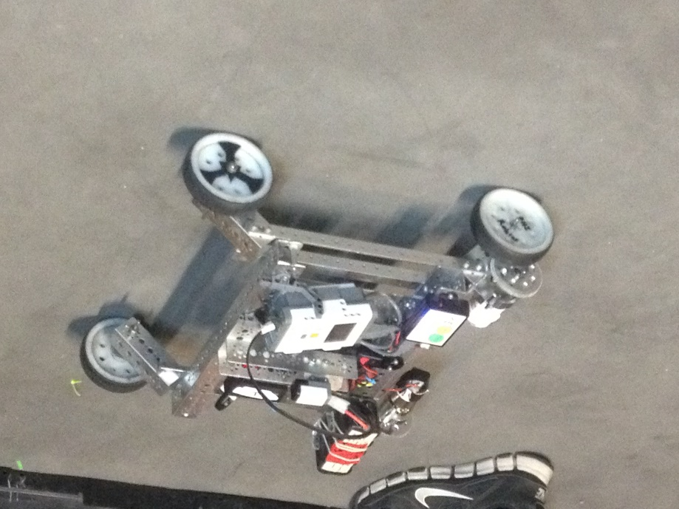
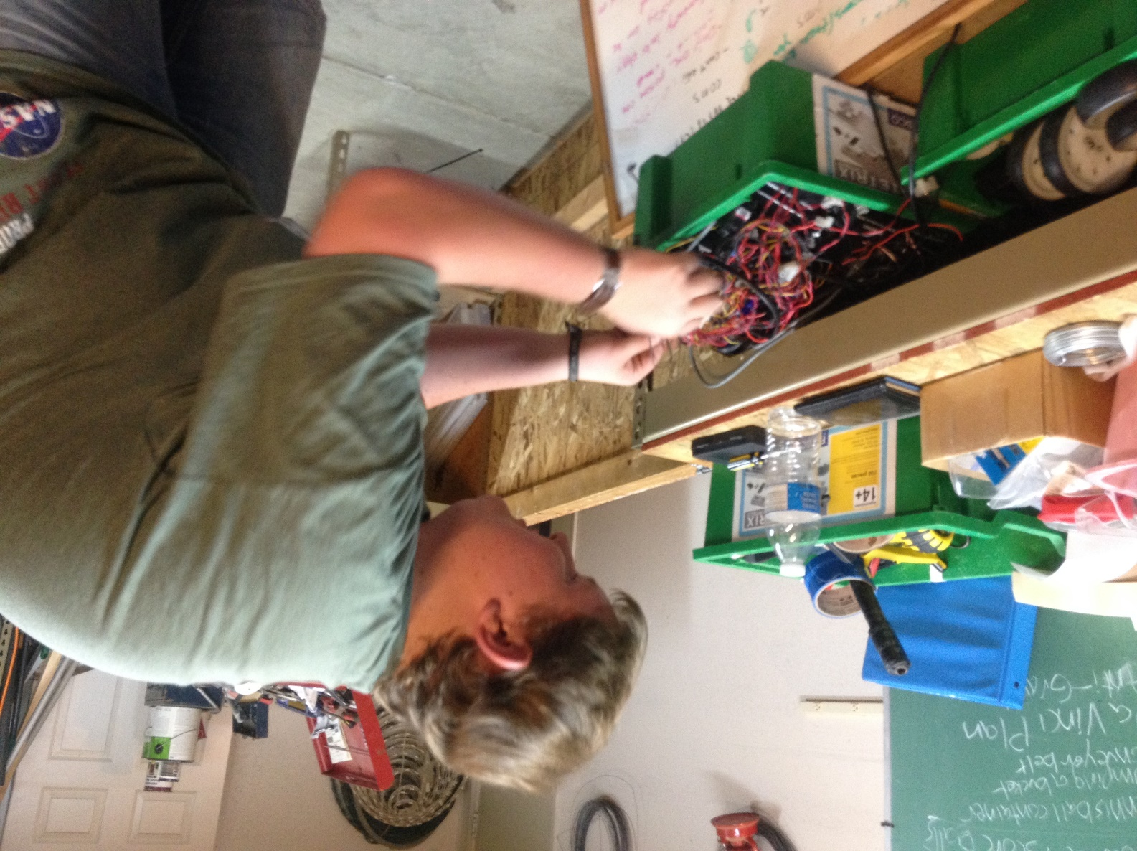
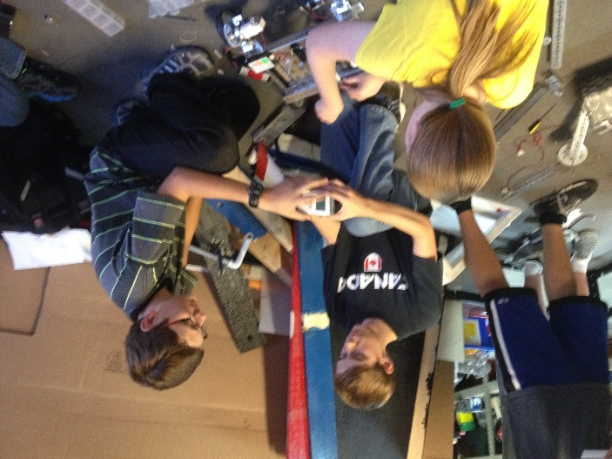

HARDWARE

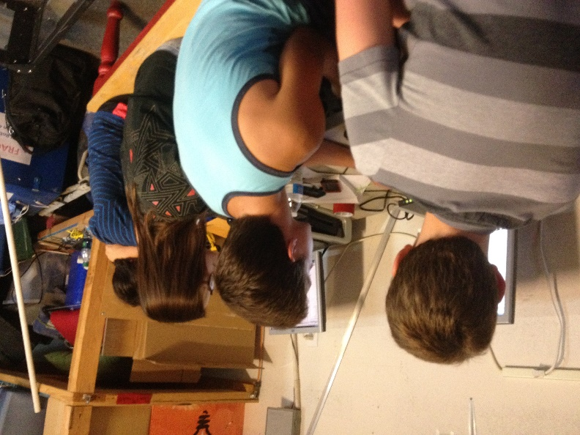
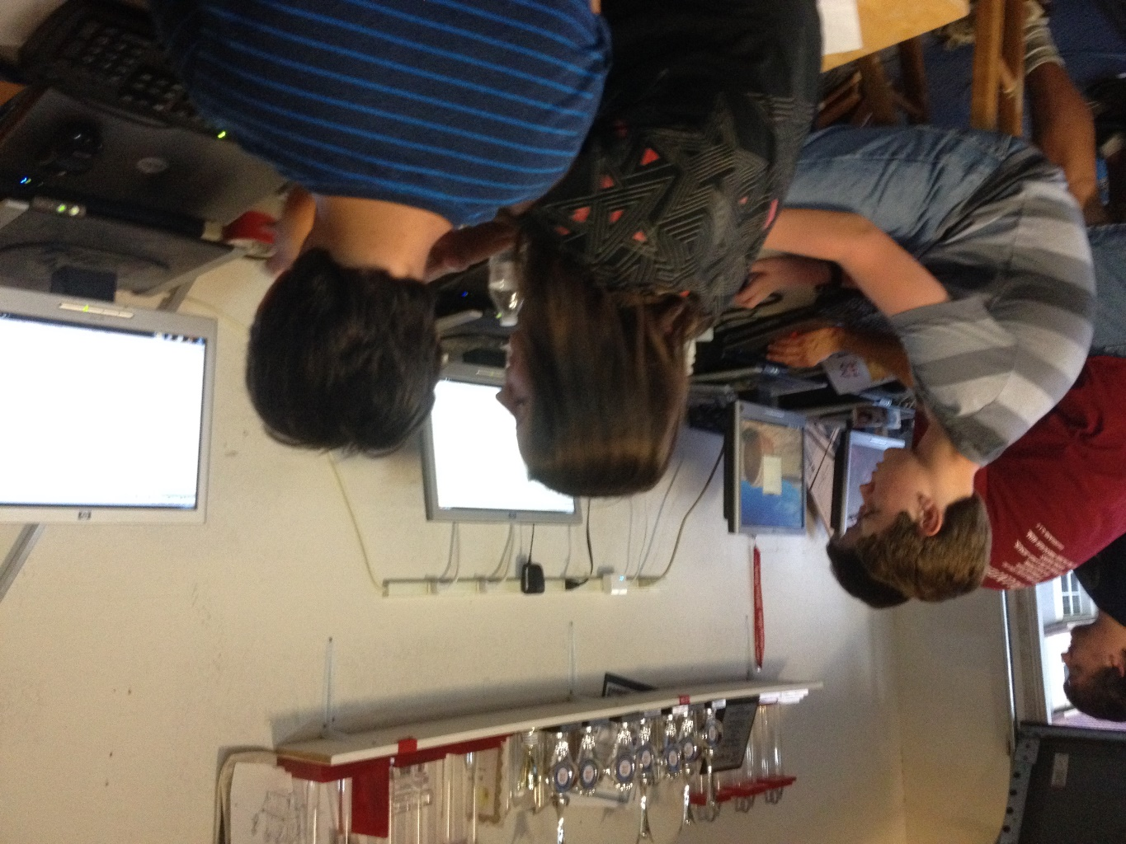
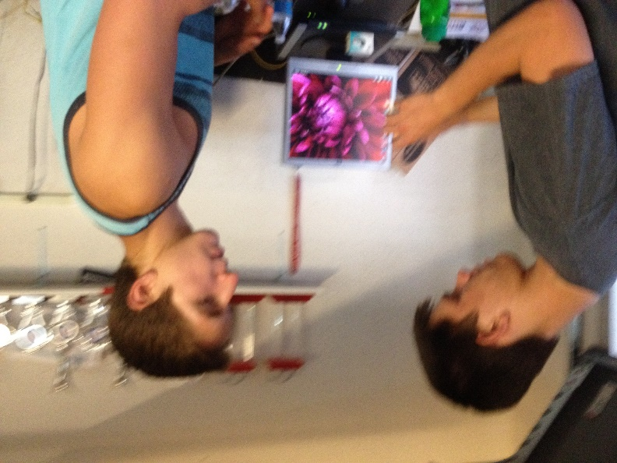
SOFTWARE

FUNDRAISING

TEAM ORGANIZATION

PROMOTE VIDEO

